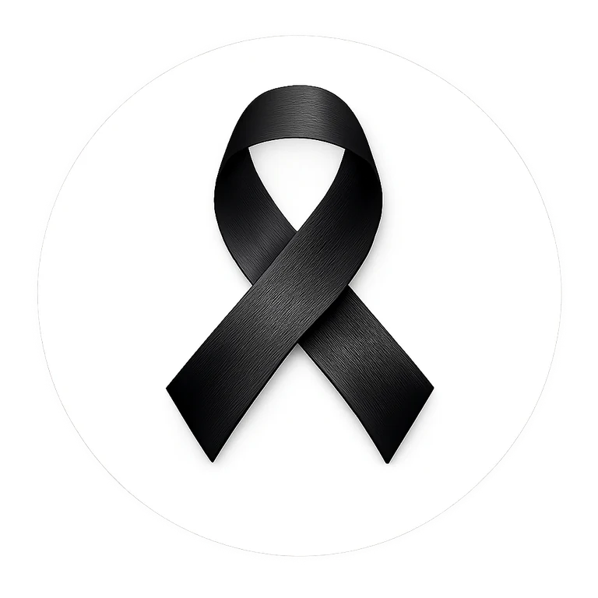
BLACK RIBBON
CAMPAIGN
RADIO & MEDIA OUTREACH PACK
Broadcaster-ready scripts, live reads, outreach copy and production notes
CAMPAIGN MESSAGE
One Ribbon. One Message. One Movement.
Unity and strength in the fight against racism and intolerance.

Website: blackribboncampaign.com
Campaign action: Wear black on the first and last day of February
Primary CTA: Take the pledge. Get your ribbon. Join the movement.

BROADCASTER QUICK START
Use this page when sending material to radio stations, community broadcasters, DJs and podcast hosts.
RECOMMENDED PACKAGE
- 30-second inspirational PSA - One Ribbon. One Message.
- 30-second Afro-pop/reggae spot - Black Ribbon Up!
- 45-second spoken-word PSA - What Will You Stand For?
- 15-second live-read tag for announcers and DJs
- Station outreach email + short follow-up
- Campaign fact sheet and pronunciation / production notes
SUGGESTED ROTATION
Run the 30-second spots in general rotation, use the 45-second PSA in community/public-affairs inventory, and give the 15-second live read to hosts for interviews, event mentions and donated airtime.
CORE INFORMATION
Campaign | Black Ribbon Campaign
Website | blackribboncampaign.com
Symbol | Black Ribbon
Wear Black Days | First and last day of February
Message | Unity and strength in the fight against racism and intolerance
BROADCAST NOTE
Keep the website spoken slowly and clearly: black-ribbon-campaign dot info. Music and effects should never overpower the call to action.

RADIO AD 1 - ONE RIBBON. ONE MESSAGE.
Target length: 30 seconds | Tone: inspirational, sincere, uplifting
SUNO PRODUCTION DIRECTION
Inspirational cinematic soul-pop. Warm piano, light percussion, uplifting choir, powerful male and female voices, clear spoken announcer, emotional build. Keep the announcer intelligible and the final website clean.
SCRIPT
[SFX] Soft heartbeat -> warm piano begins
[ANNOUNCER] Racism divides. Unity brings us together.
[ANNOUNCER] This Black History Month, wear a Black Ribbon as a symbol of unity and strength in the fight against racism and intolerance.
[MUSIC] Build gently
[SUNG - GROUP] One ribbon, one message, stand together, stand strong!
[ANNOUNCER] Wear black on the first and last day of February. Take the pledge. Get your ribbon. Share the message.
[CHOIR] Black Ribbon Up!
[ANNOUNCER] Join the movement at blackribboncampaign.com.
[TAG] Black Ribbon Campaign. Unity. Strength. Action.
MIX NOTE
Aim for a clean 29-30 second master. Leave a fraction of a second of silence at the head and tail for broadcast automation.

RADIO AD 2 - BLACK RIBBON UP!
Target length: 30 seconds | Tone: energetic, memorable, community-driven
SUNO PRODUCTION DIRECTION
Energetic Afro-pop / reggae fusion radio jingle. Bright percussion, bass groove, handclaps, crowd chants and joyful ensemble vocals. Catchy hook, but keep every spoken line easy to understand.
SCRIPT
[SFX] Crowd cheer + upbeat Afro-reggae beat
[CHANT] Black Ribbon Up! Black Ribbon Up!
[ANNOUNCER] This February, we are sending one message from coast to coast: We stand together against racism and intolerance!
[SUNG HOOK] Wear it! Share it! Let the whole world see! Black Ribbon Up for unity!
[ANNOUNCER] Wear black on the first and last day of February. Get your Black Ribbon. Take the pledge. Invite your family, school, workplace and community.
[CROWD] One ribbon! One message! One movement!
[ANNOUNCER] Join us now at blackribboncampaign.com.
[CHANT OUT] Black Ribbon Up!
MIX NOTE
The hook can be sung with energy, but reduce the music bed under the website and final CTA.

RADIO AD 3 - WHAT WILL YOU STAND FOR?
Target length: 45 seconds | Tone: serious opening, hopeful and triumphant finish
SUNO PRODUCTION DIRECTION
Modern spoken-word PSA with dramatic drums, a deep bass pulse and restrained gospel/soul choir accents. Male narrator or grounded low female narrator. Build from reflective to powerful without sounding aggressive.
SCRIPT
[SFX] Single deep drum beat. Brief silence.
[NARRATOR] What do you do when someone is judged by the colour of their skin? When hatred tries to divide a classroom... a workplace... a neighbourhood... a country?
[CHOIR] Soft choir enters
[NARRATOR] You stand. Not as Black. Not as White. Not as one race against another. You stand together.
[MUSIC] Rise
[NARRATOR] This Black History Month, wear a Black Ribbon - a simple symbol with a powerful message: Racism and intolerance have no place among us.
[GROUP] Unity. Strength. Respect. Action.
[NARRATOR] Wear black on the first and last day of February. Take the pledge. Get your ribbon. Bring your school, workplace, family and community with you.
[CHOIR - SUNG] One ribbon... one message... one movement.
[NARRATOR] The Black Ribbon Campaign. Join the movement at blackribboncampaign.com.

LIVE READS & STATION TAGS
Short copy for DJs, hosts, interview intros, donated airtime and sponsorship mentions.
15-SECOND LIVE READ
15 SECONDS
This February, wear a Black Ribbon and stand for unity and strength in the fight against racism and intolerance. Wear black on the first and last day of February. Take the pledge at blackribboncampaign.com.

10-SECOND STATION TAG
10 SECONDS
One ribbon. One message. One movement. Join the Black Ribbon Campaign at blackribboncampaign.com.

HOST INTRO FOR INTERVIEW
Across schools, workplaces, families and communities, the Black Ribbon Campaign is inviting people to wear a Black Ribbon as a visible symbol of unity and strength against racism and intolerance. We are joined today by [NAME / TITLE] to tell us how listeners can take part.
EVENT MENTION
A reminder from the Black Ribbon Campaign: wear black on the first and last day of February, take the pledge, and invite your community to join you. Learn more at blackribboncampaign.com.

RADIO STATION OUTREACH
Ready-to-customize email and follow-up copy.
INITIAL EMAIL
Subject: Community PSA Request - Black Ribbon Campaign
Hello [Station / Program Director / Community Affairs Team],
The Black Ribbon Campaign is inviting radio stations and media partners to help share a simple message of unity and strength in the fight against racism and intolerance. During Black History Month, participants are encouraged to wear a Black Ribbon and to wear black on the first and last day of February.
We have prepared broadcaster-ready 30-second and 45-second campaign spots, plus a short live-read script. We would be grateful if your station would consider airing the PSA, sharing the campaign during community programming, or inviting a representative for a brief interview.
Campaign website: blackribboncampaign.com
Audio / scripts: [INSERT DOWNLOAD OR MEDIA KIT LINK]
Thank you for helping make space for a message that communities can stand behind together.
Sincerely,
[NAME]
[TITLE]
Black Ribbon Campaign
[EMAIL] | [PHONE]
SHORT FOLLOW-UP
Subject: Follow-up - Black Ribbon Campaign PSA
Hello [NAME], I am following up on the Black Ribbon Campaign PSA sent recently. If your station has community-service inventory, interview availability or a local events segment, we would be grateful for the opportunity to share the campaign. The materials are ready for broadcast, and the central information is available at blackribboncampaign.com. Thank you for considering it.

CAMPAIGN FACT SHEET
Use this page as the reference sheet attached to broadcaster outreach.
WHAT IT IS
A public awareness campaign using the Black Ribbon as a visible symbol of unity and strength in the fight against racism and intolerance.
WHAT PEOPLE DO
Wear a Black Ribbon, take the pledge, wear black on the first and last day of February, share the message, and invite schools, workplaces, organizations and communities to participate.
CORE MESSAGE
One Ribbon. One Message. One Movement.
WEBSITE
blackribboncampaign.com
SUGGESTED INTERVIEW TOPICS
Why the Black Ribbon was chosen; how schools and workplaces can participate; why visible symbols matter; community involvement; campaign action days; how listeners can take the pledge.
MEDIA CONTACT
[NAME] | [TITLE] | [EMAIL] | [PHONE]
PRONUNCIATION
Say the website as: "black ribbon campaign dot info." Avoid rushing the web address in live reads.

FINAL PRODUCTION CHECKLIST
- Export a clean broadcast WAV or high-quality MP3 master.
- Create clearly named files with duration in the filename.
- Check final runtime with a stopwatch after mastering.
- Keep spoken website and CTA above the music bed.
- Add station-specific legal/tag copy only if requested.
- Store final masters in the Campaign Toolkit under Campaign Music / Radio & Media.

