BLACK RIBBON CAMPAIGN
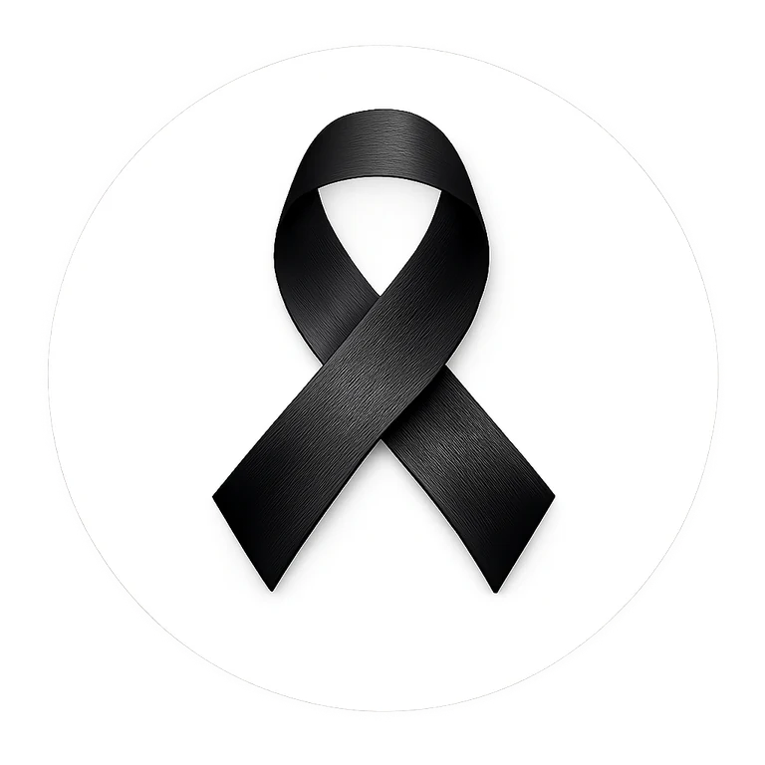
SCHOOL MATERIALS TOOLKIT
Wear Black. Take the Pledge. Stand Together.
Ready-to-use materials for schools, educators, student leaders, families and community partners.
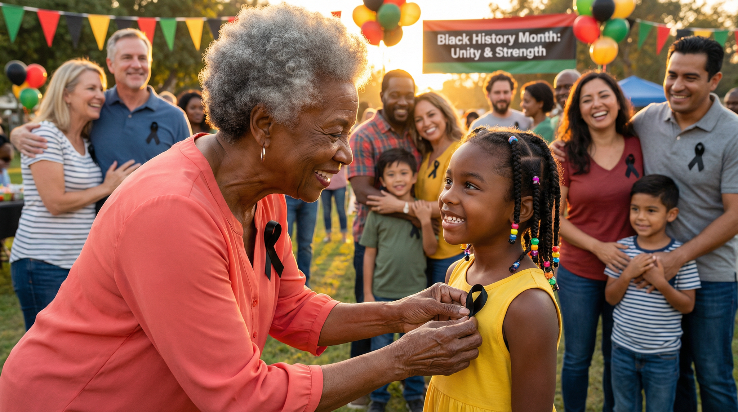
Campaign message
Wear a Black Ribbon as a symbol of unity and strength in the fight against racism, intolerance and discrimination. Schools are encouraged to wear black on the first and last day of February and to use the campaign as an opportunity for respectful, age-appropriate learning and community action.

blackribboncampaign.com

How to Use This Toolkit
A simple school participation plan

A flexible school campaign
Schools can participate at a level that fits their community. The campaign is designed to support respectful discussion, visible solidarity and positive action without requiring a single lesson format or assembly model.
- Wear black on February 1 and the final day of February. If either date falls on a weekend, holiday or closure, schools may recognize the campaign on the nearest instructional day while still promoting the official date.
- Make black ribbons available to students, staff and families who choose to participate.
- Use the morning announcements, classroom discussion guide and pledge materials in this toolkit.
- Invite students to create positive messages about unity, respect and belonging.
- Share approved photos or stories through the Black Ribbon Campaign website and your school channels, following school consent rules.
Recommended school sequence
1 week before: announce participation and send family notice. 2-3 days before: prepare ribbons, posters and classroom prompts. Campaign day: wear black, distribute ribbons, make the announcement and offer the pledge. Afterward: reflect, celebrate positive participation and share approved stories.

Core principles
- Participation should be voluntary and welcoming.
- Use age-appropriate language and allow students to ask questions respectfully.
- Focus on dignity, belonging, fairness, empathy and constructive action.
- Follow school board policies for photography, media, family communication and student privacy.

School Administrator & Principal Guide
Planning, safety and coordination

Purpose
The Black Ribbon Campaign gives schools a visible, nonviolent symbol for standing against racism and intolerance while encouraging unity, strength and respectful action. The school can participate through dress, ribbon distribution, announcements, classroom learning, assemblies, student leadership and community engagement.

Administrator checklist
☐ Identify a staff coordinator or student leadership contact.
☐ Choose which campaign activities the school will use.
☐ Confirm the nearest instructional day if February 1 or the final day of February is not a school day.
☐ Order or prepare black ribbons in advance.
☐ Review family communication and photo/media consent requirements.
☐ Brief teachers and office staff on the campaign message and student questions.
☐ Share the morning announcement and display approved posters.
☐ Decide whether the school will submit a story or photo to the campaign website.
Suggested school statement
“Our school is participating in the Black Ribbon Campaign as a symbol of unity and strength in the fight against racism and intolerance. Participation is voluntary. We encourage respectful conversation, empathy and actions that help every member of our school community feel valued and included.”

School contact information
School _______________________________________________________
Campaign Coordinator _______________________________________________________
Email _______________________________________________________
Phone _______________________________________________________
Campaign Date(s) _______________________________________________________

Family / Parent / Guardian Letter
Editable sample communication

[SCHOOL NAME]
[DATE]
Dear Parents, Guardians and Families,
Our school is participating in the Black Ribbon Campaign during Black History Month. The Black Ribbon is worn as a symbol of unity and strength in the fight against racism, intolerance and discrimination.
Students and staff are invited to wear black and/or a Black Ribbon on the first and last day of February. If one of those dates is not an instructional day, our school will recognize the campaign on [SCHOOL DATE]. Participation is voluntary.
The campaign provides an opportunity for age-appropriate learning and conversation about respect, belonging, fairness, empathy and the responsibility we all share to build welcoming communities. Our school activities may include morning announcements, classroom discussion, student pledges, ribbon distribution and positive messages of unity.
Families are welcome to participate at home and to talk with students about what it means to stand against racism and intolerance in everyday life.
For more information about the campaign, visit blackribboncampaign.com.
Thank you for helping us create a school community where every student is treated with dignity and respect.
Sincerely,
Principal / School Representative _______________________________________________________

Morning Announcement Scripts
Ready to read over PA, video or homeroom

One week before
SCRIPT
Next week, our school will take part in the Black Ribbon Campaign. The Black Ribbon is a symbol of unity and strength in the fight against racism and intolerance. Students and staff are invited to wear black and/or a Black Ribbon on [DATE]. Watch for more information about how you can participate.

Day before
SCRIPT
Tomorrow is our Black Ribbon Campaign day. We invite everyone who chooses to participate to wear black and a Black Ribbon. The ribbon is a visible reminder that respect, dignity and belonging matter in our school. Let us show what it looks like when a school community stands together.

Campaign day - opening
SCRIPT
Today we wear black. Today we wear the Black Ribbon. We do it as a symbol of unity and strength and as a reminder that racism, intolerance and discrimination have no place in our school community. Let your actions today - and every day - show respect, courage and kindness.

Campaign day - closing
SCRIPT
Thank you to everyone who participated in today’s Black Ribbon Campaign activities. A ribbon is a symbol, but the message is lived through our choices: how we speak, how we include others, how we respond to unfairness and how we stand together. Let’s carry that message forward.

Classroom Discussion Guide
Adaptable for elementary, middle and secondary grades

Learning goals
- Understand what an awareness symbol can represent.
- Explore the ideas of unity, dignity, fairness, belonging and respectful action.
- Recognize everyday ways people can challenge intolerance and exclusion.
- Identify one positive action students can take in their own community.

Opening prompt
Ask
What can a simple symbol communicate without using many words? Why do people use ribbons, colours, pins or other symbols to show support for a cause?

Discussion questions by age
Grade band | Suggested prompts
K-5 | What does it mean to help someone feel included? What can we do when we see someone being left out? What does respect look and sound like?
Grades 6-8 | How can stereotypes affect the way people are treated? What is the difference between being a bystander and being an upstander? How can we disagree without disrespecting someone?
Grades 9-12 | How do racism and intolerance show up in systems, institutions, media and everyday interactions? What makes allyship effective? How can communities move from symbolic support to meaningful action?

Teacher facilitation reminders
- Set expectations for respectful dialogue before beginning.
- Do not pressure students to disclose personal experiences.
- Correct harmful generalizations without shaming the student who asked the question.
- Acknowledge that people may have different levels of knowledge and experience.
- End with constructive actions students can take.

Student Pledge & Reflection
Printable student activity

MY BLACK RIBBON PLEDGE
My pledge
I will wear the Black Ribbon as a symbol of unity and strength. I will stand against racism, intolerance and discrimination by treating others with dignity, speaking up respectfully when something is wrong, and helping build a community where people feel they belong.

My reflection
To me, unity means...
_______________________________________________________________________________________________
_______________________________________________________________________________________________
One way I can help someone feel included is...
_______________________________________________________________________________________________
_______________________________________________________________________________________________
If I hear or see something unfair, I can...
_______________________________________________________________________________________________
_______________________________________________________________________________________________
One action I will take this month is...
_______________________________________________________________________________________________
_______________________________________________________________________________________________
Student Name (optional) _______________________________________________________
Class / Grade _______________________________________________________
Remember
Taking the pledge is voluntary. The goal is to think about how our everyday choices can support dignity, respect and belonging.

Classroom Activity - One Ribbon, One Message
20-30 minute collaborative activity

Objective
Students create short positive messages that explain what unity, strength, respect and belonging look like in real life. The messages can be displayed around a large Black Ribbon shape or classroom bulletin board.

Materials
- Black ribbon image or large paper ribbon
- Black, gold, red, green and white paper/cards
- Markers or pens
- Tape or removable adhesive

Steps
- Introduce the Black Ribbon Campaign and explain the symbol.
- Ask each student to choose one word: UNITY, STRENGTH, RESPECT, BELONGING or ACTION.
- On a card, write one sentence that begins: “I can show ___ by…”
- Invite students to place their cards around the Black Ribbon display.
- Read a selection aloud and discuss which actions can continue beyond Black History Month.
Display title
ONE RIBBON. ONE MESSAGE. - Our class stands for dignity, respect and belonging.

School Assembly Outline
20-30 minute adaptable program

Program | Notes
1. Welcome - 2 min | Explain why the school is participating and that participation is voluntary.
2. Meaning of the Black Ribbon - 3 min | Describe the ribbon as a symbol of unity and strength in the fight against racism and intolerance.
3. Student voice - 5 min | Student leaders share brief reflections, poetry, quotations or personal commitments approved by the school.
4. Learning moment - 7 min | Teacher, guest or student panel discusses respect, stereotypes, belonging and constructive action.
5. Pledge - 3 min | Invite students who wish to participate to read or silently consider the Black Ribbon pledge.
6. Action challenge - 3 min | Ask every class or grade to choose one concrete action that strengthens belonging.
7. Closing - 2 min | End with: “One Ribbon. One Message. Unity. Strength. Action.”
Optional additions
Student music or spoken word, a short video, local community guest, school equity club presentation, ribbon pinning demonstration, or a display of student unity messages.

Student Leadership & School Club Guide
Ways students can lead responsibly

Student-led ideas
- Operate a ribbon table before school or at lunch with staff oversight.
- Create a hallway “One Ribbon, One Message” display.
- Record a 30-second school video explaining why students are wearing black.
- Invite classes to submit one unity action or message.
- Host a lunchtime discussion or moderated student panel.
- Create approved social posts for the school account.
- Collect approved stories for submission to the Black Ribbon Campaign website.

Suggested student leader roles
☐ Campaign Coordinator
☐ Announcement Team
☐ Ribbon Table Team
☐ Poster & Display Team
☐ Assembly Team
☐ Story/Media Team
☐ Reflection & Feedback Team
Student safety & respect
Student leaders should work with a staff advisor, avoid pressuring peers to participate, protect private information, and follow school rules for photography, social media and public statements.

School Social Media & Newsletter Copy
Ready-to-adapt text

Short social caption
COPY
Our school is joining the Black Ribbon Campaign. We will wear black and the Black Ribbon as a symbol of unity and strength in the fight against racism and intolerance. One Ribbon. One Message. #BlackRibbonCampaign #WearBlack

Family newsletter blurb
COPY
During Black History Month, [SCHOOL NAME] will participate in the Black Ribbon Campaign. Students and staff are invited to wear black and/or a Black Ribbon on [DATE]. The campaign promotes unity, strength, dignity and respectful action in the fight against racism and intolerance. Participation is voluntary. Learn more at blackribboncampaign.com.

Website notice
COPY
[SCHOOL NAME] is proud to participate in the Black Ribbon Campaign. Through classroom learning, student leadership and visible solidarity, we are encouraging our community to stand together against racism, intolerance and discrimination.

Photo, Story & Media Checklist
Use before sharing campaign content

☐ Confirm school/board media consent requirements.
☐ Do not publish student names with photos unless permission clearly allows it.
☐ Avoid showing confidential student information, timetables or personal records.
☐ Use respectful captions focused on campaign participation.
☐ Confirm permission before submitting a story or photo to the Black Ribbon Campaign website.
☐ Keep original consent/permission records according to school policy.
Recommended caption
“Students and staff at [SCHOOL NAME] stand together through the Black Ribbon Campaign - a symbol of unity and strength in the fight against racism and intolerance.”

School Participation Report
Optional internal tracking sheet

School _______________________________________________________
City / Province _______________________________________________________
Coordinator _______________________________________________________
Campaign Date _______________________________________________________

Participation snapshot
Estimated students participating
Estimated staff participating
Black ribbons distributed
Classes using discussion materials
Assembly / event attendance
Stories or photos submitted

What worked well?
_______________________________________________________________________________________________
_______________________________________________________________________________________________
_______________________________________________________________________________________________
_______________________________________________________________________________________________

What would we improve next year?
_______________________________________________________________________________________________
_______________________________________________________________________________________________
_______________________________________________________________________________________________
_______________________________________________________________________________________________

Printable School Poster
Display on bulletin boards, classroom doors and common areas

WEAR BLACK
FIRST AND LAST DAY OF FEBRUARY
Wear a Black Ribbon as a symbol of unity and strength in the fight against racism and intolerance.
ONE RIBBON. ONE MESSAGE.
blackribboncampaign.com

Proud Participating School Certificate
Print and display after participation

PROUD PARTICIPATING SCHOOL
BLACK RIBBON CAMPAIGN
This certificate recognizes
[SCHOOL NAME]
for standing together in unity and strength in the fight against racism and intolerance.
ONE RIBBON. ONE MESSAGE.
Date: ___________________________ School Representative: ___________________________
blackribboncampaign.com

