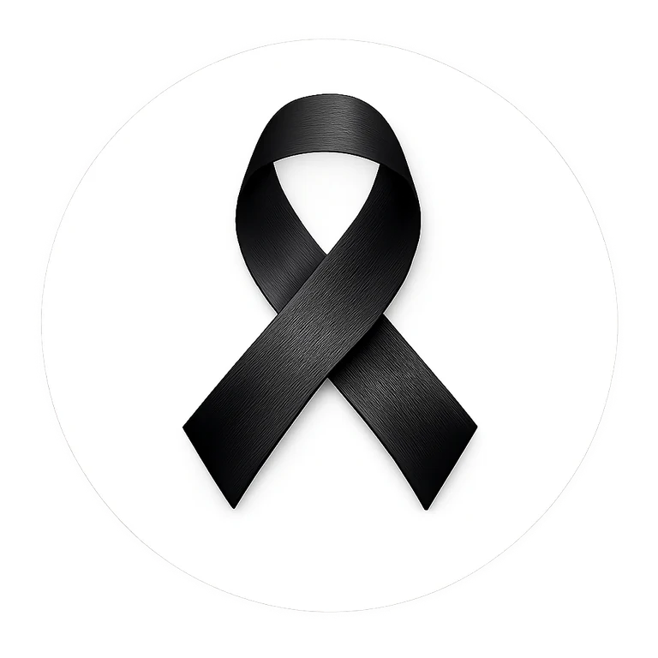 | Family / Parent / Guardian Letter  Editable school communication

[SCHOOL NAME]
[DATE]
Dear Parents, Guardians and Families,
Our school is participating in the Black Ribbon Campaign during Black History Month. The Black Ribbon is worn as a symbol of unity and strength in the fight against racism, intolerance and discrimination.
Students and staff are invited to wear black and/or a Black Ribbon on the first and last day of February. If one of those dates is not an instructional day, our school will recognize the campaign on [SCHOOL DATE]. Participation is voluntary.
The campaign provides an opportunity for age-appropriate learning and conversation about respect, belonging, fairness, empathy and the responsibility we all share to build welcoming communities. Our school activities may include morning announcements, classroom discussion, student pledges, ribbon distribution and positive messages of unity.
Families are welcome to participate at home and to talk with students about what it means to stand against racism and intolerance in everyday life.
For more information about the campaign, visit blackribboncampaign.com.
Thank you for helping us create a school community where every student is treated with dignity and respect.
Sincerely,
Principal / School Representative _______________________________________________________

