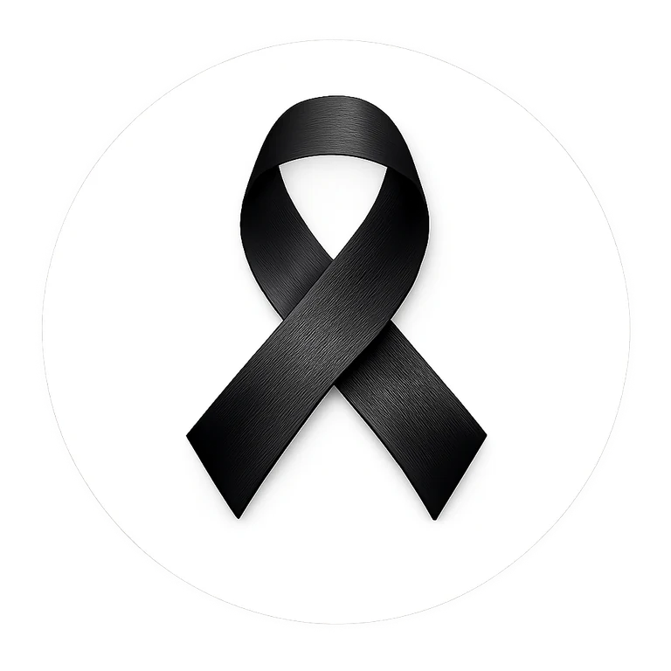 | Morning Announcement Scripts  School-ready scripts

One week before
SCRIPT
Next week, our school will take part in the Black Ribbon Campaign. The Black Ribbon is a symbol of unity and strength in the fight against racism and intolerance. Students and staff are invited to wear black and/or a Black Ribbon on [DATE]. Watch for more information about how you can participate.

Day before
SCRIPT
Tomorrow is our Black Ribbon Campaign day. We invite everyone who chooses to participate to wear black and a Black Ribbon. The ribbon is a visible reminder that respect, dignity and belonging matter in our school. Let us show what it looks like when a school community stands together.

Campaign day - opening
SCRIPT
Today we wear black. Today we wear the Black Ribbon. We do it as a symbol of unity and strength and as a reminder that racism, intolerance and discrimination have no place in our school community. Let your actions today - and every day - show respect, courage and kindness.

Campaign day - closing
SCRIPT
Thank you to everyone who participated in today’s Black Ribbon Campaign activities. A ribbon is a symbol, but the message is lived through our choices: how we speak, how we include others, how we respond to unfairness and how we stand together. Let’s carry that message forward.

