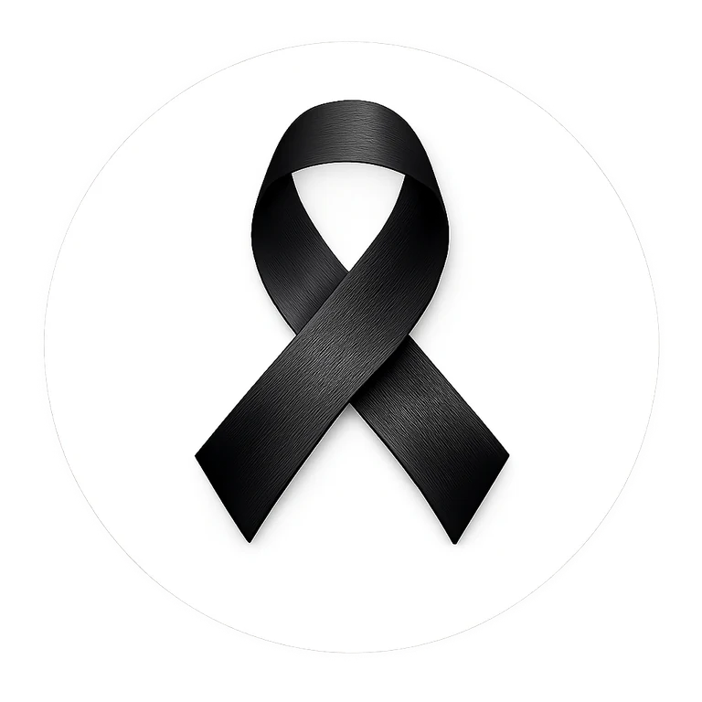
BLACK RIBBON CAMPAIGN
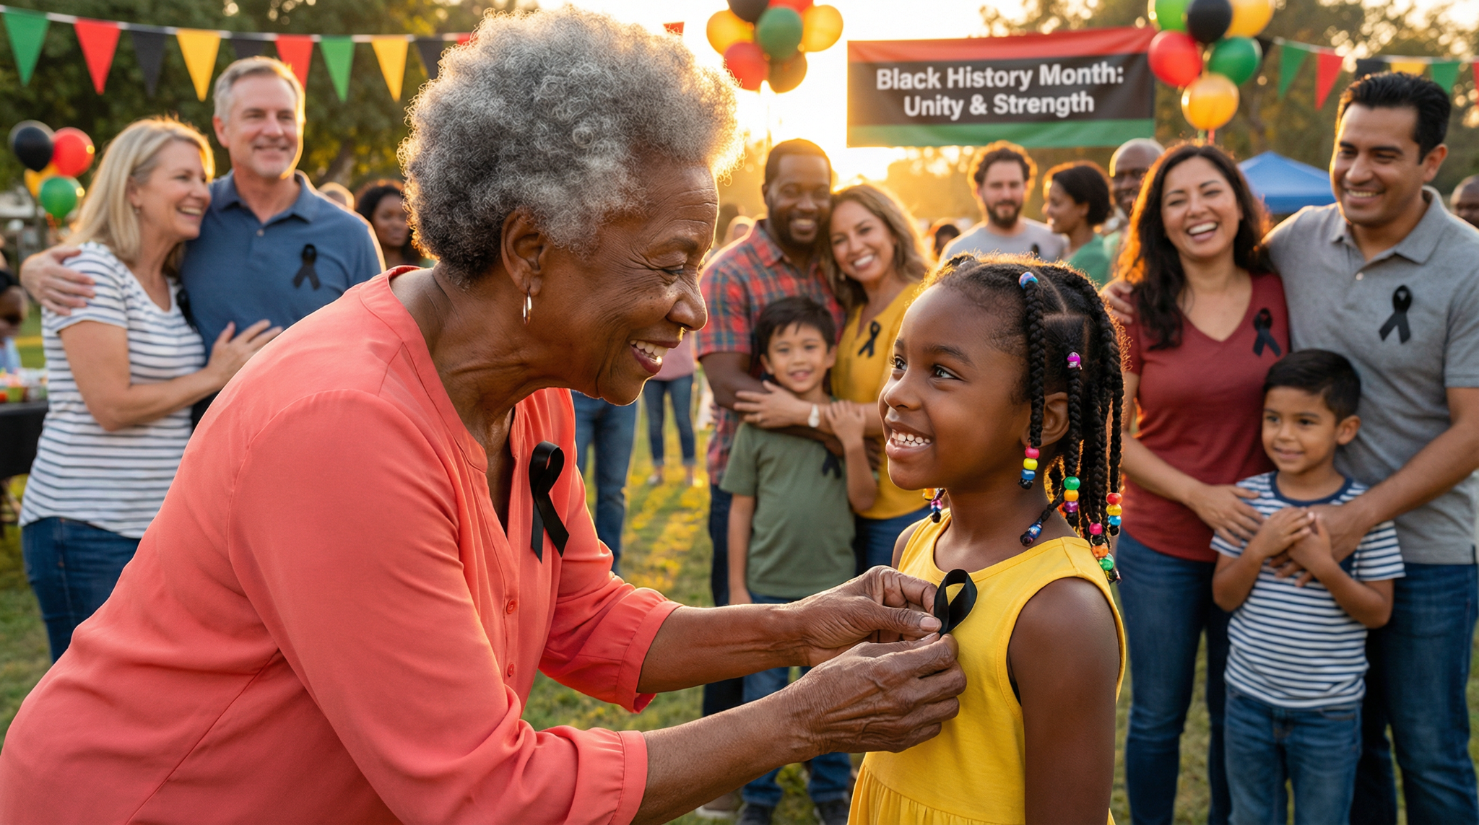
WEAR BLACK
FIRST AND LAST DAY OF FEBRUARY
Wear a Black Ribbon as a symbol of unity and strength in the fight against racism and intolerance.
ONE RIBBON. ONE MESSAGE.
blackribboncampaign.com

