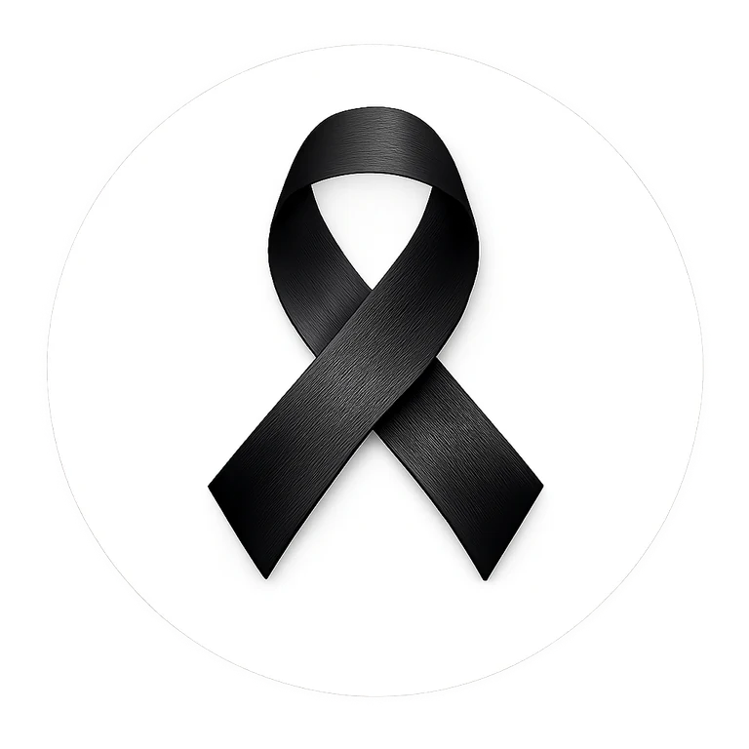
PROUD PARTICIPATING SCHOOL
BLACK RIBBON CAMPAIGN
This certificate recognizes
[SCHOOL NAME]
for standing together in unity and strength in the fight against racism and intolerance.
ONE RIBBON. ONE MESSAGE.
Date: _____________________ School Representative: _____________________
blackribboncampaign.com

