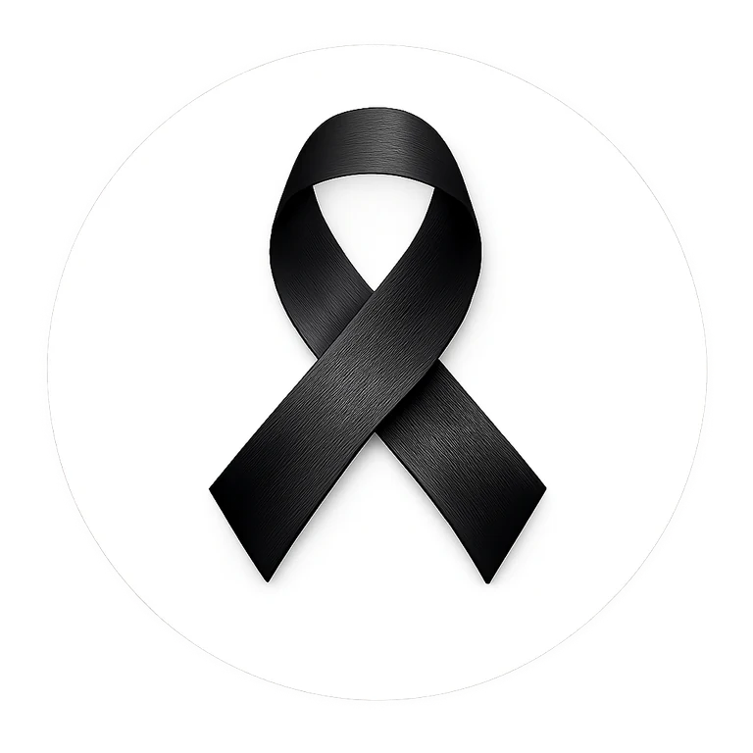 | School Assembly Outline  20-30 minute adaptable program

1. Welcome - 2 min
Explain why the school is participating and that participation is voluntary.

2. Meaning of the Black Ribbon - 3 min
Describe the ribbon as a symbol of unity and strength in the fight against racism and intolerance.

3. Student voice - 5 min
Student leaders share brief reflections, poetry, quotations or personal commitments approved by the school.

4. Learning moment - 7 min
Teacher, guest or student panel discusses respect, stereotypes, belonging and constructive action.

5. Pledge - 3 min
Invite students who wish to participate to read or silently consider the Black Ribbon pledge.

6. Action challenge - 3 min
Ask every class or grade to choose one concrete action that strengthens belonging.

7. Closing - 2 min
End with: “One Ribbon. One Message. Unity. Strength. Action.”
Closing line
ONE RIBBON. ONE MESSAGE. UNITY. STRENGTH. ACTION.

