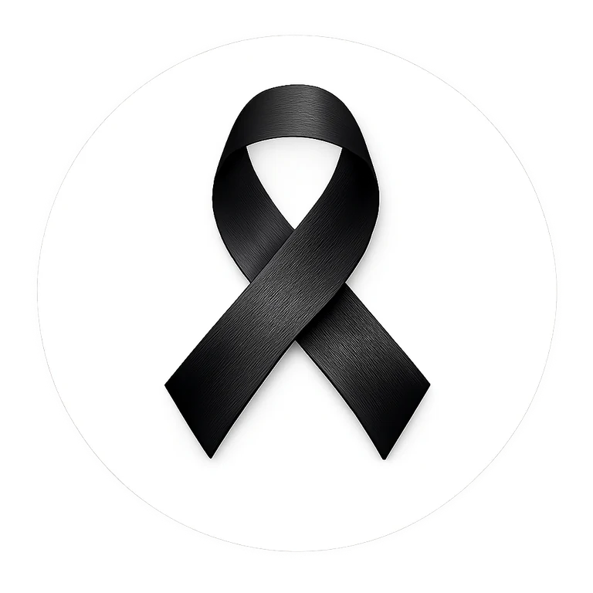 | Student Pledge & Reflection  Printable student activity

MY BLACK RIBBON PLEDGE
My pledge
I will wear the Black Ribbon as a symbol of unity and strength. I will stand against racism, intolerance and discrimination by treating others with dignity, speaking up respectfully when something is wrong, and helping build a community where people feel they belong.

To me, unity means...
_______________________________________________________________________________________________
_______________________________________________________________________________________________
One way I can help someone feel included is...
_______________________________________________________________________________________________
_______________________________________________________________________________________________
If I hear or see something unfair, I can...
_______________________________________________________________________________________________
_______________________________________________________________________________________________
One action I will take this month is...
_______________________________________________________________________________________________
_______________________________________________________________________________________________
Student Name (optional) _______________________________________________________
Class / Grade _______________________________________________________

