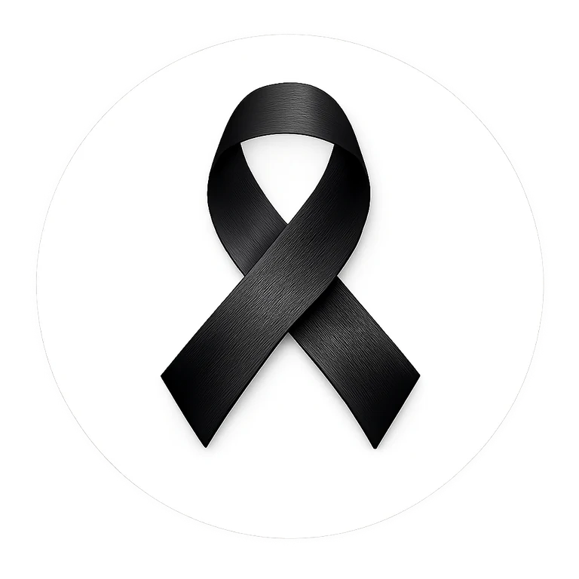
BLACK RIBBON CAMPAIGN
WORKPLACE MESSAGES
Ready-to-use communications for employers, HR teams, managers, staff groups and workplace champions
WEAR BLACK • FIRST AND LAST DAY OF FEBRUARY

A symbol of unity and strength in the fight against racism and intolerance.
Use these messages as written or adapt them to your organization’s voice, policies and audience.
Campaign website: blackribboncampaign.com
Workplace participation should be voluntary and consistent with applicable dress, safety, accommodation and employment policies.

QUICK REFERENCE

Copy-and-Paste Quick Messages
LAUNCH
We are supporting the Black Ribbon Campaign this Black History Month. Wear a black ribbon as a symbol of unity and strength in the fight against racism and intolerance. Employees who wish to participate are also invited to wear black on the first and last day of February. blackribboncampaign.com

DAY BEFORE
Reminder: tomorrow is a Wear Black day for the Black Ribbon Campaign. Participation is voluntary - wear black and/or a black ribbon if you would like to show your support. 🖤

FEBRUARY 1
Today we wear black. 🖤 One ribbon. One message. Unity and strength in the fight against racism and intolerance. blackribboncampaign.com

PLEDGE
Take the Black Ribbon pledge and make your commitment visible: blackribboncampaign.com

FINAL DAY
Today we wear black as we close Black History Month with a message of unity and strength. The commitment continues beyond February. 🖤 blackribboncampaign.com

THANK YOU
Thank you to everyone who participated in the Black Ribbon Campaign. Every ribbon, conversation and act of respect helped carry the message. Keep standing together.

