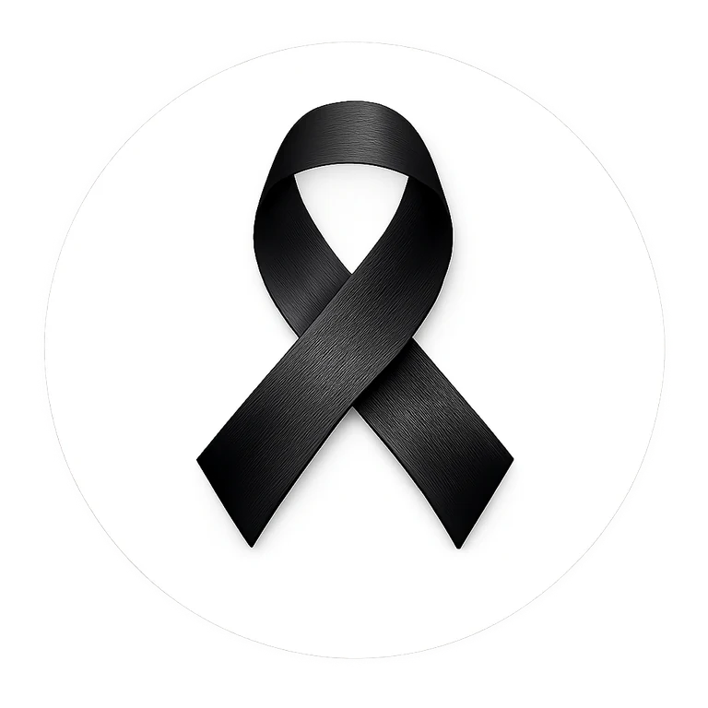
BLACK RIBBON CAMPAIGN
WORKPLACE MESSAGES
Ready-to-use communications for employers, HR teams, managers, staff groups and workplace champions
WEAR BLACK • FIRST AND LAST DAY OF FEBRUARY

A symbol of unity and strength in the fight against racism and intolerance.
Use these messages as written or adapt them to your organization’s voice, policies and audience.
Campaign website: blackribboncampaign.com
Workplace participation should be voluntary and consistent with applicable dress, safety, accommodation and employment policies.

QUICK START

How to Use This Message Pack
These messages are designed for Canadian workplaces and can be adapted for companies, nonprofits, unions, professional associations, public agencies and community organizations. Participation in campaign activities should be voluntary and inclusive.

Recommended communication sequence
- 2-4 weeks before February: leadership announcement and intranet/newsletter post.
- Week before February 1: staff reminder and manager talking points.
- February 1: morning message encouraging voluntary Wear Black participation and black-ribbon visibility.
- Mid-month: short reminder, story, pledge or ribbon message.
- Last day of February: final-day Wear Black reminder and unity message.
- After the campaign: thank-you note and invitation to keep the message going year-round.

Core campaign language
CAMPAIGN STATEMENT
The Black Ribbon Campaign invites people to wear a black ribbon as a visible symbol of unity and strength in the fight against racism and intolerance. During Black History Month, supporters are also encouraged to wear black on the first and last day of February to show solidarity and help carry the message from workplace to workplace, community to community, and coast to coast.

Workplace inclusion note
OPTIONAL FOOTER FOR INTERNAL MESSAGES
Participation is voluntary. Employees may participate in ways that are comfortable and appropriate for them. Please follow workplace dress, safety, uniform and accommodation requirements.

EXECUTIVES & SENIOR LEADERS

Leadership Launch Messages
FULL LEADERSHIP EMAIL
Subject: Our Workplace Is Standing with the Black Ribbon Campaign
Colleagues,
During Black History Month, our workplace is invited to participate in the Black Ribbon Campaign - a movement that uses the black ribbon as a visible symbol of unity and strength in the fight against racism and intolerance.
We encourage employees who wish to participate to wear a black ribbon and, on the first and last day of February, to wear black as an additional show of support.
This is a simple act, but the message matters: racism and intolerance have no place in our workplace or our communities. Respect, dignity and belonging are responsibilities we share.
Participation is voluntary. We invite everyone to learn more, take the pledge, share the message and help create a workplace where people are treated with fairness and respect.
Learn more: blackribboncampaign.com
Thank you for helping us stand together.

SHORT LEADERSHIP NOTE
Subject: Black Ribbon Campaign - Unity & Strength
This Black History Month, we are supporting the Black Ribbon Campaign. Employees who wish to participate are invited to wear a black ribbon and wear black on the first and last day of February as a visible show of unity and strength in the fight against racism and intolerance.
Participation is voluntary. Learn more at blackribboncampaign.com.

INTERNAL CULTURE

HR / People & Culture Messages
HR ANNOUNCEMENT
Subject: Voluntary Black Ribbon Campaign Participation
As part of our Black History Month activities, employees are invited to participate in the Black Ribbon Campaign. The campaign encourages people to wear a black ribbon as a symbol of unity and strength in the fight against racism and intolerance.
Employees may also choose to wear black on the first and last day of February. Participation is voluntary and should be consistent with any safety, uniform, dress-code or accommodation requirements that apply to your role.
Ways to participate:
• Wear a black ribbon.
• Wear black on the first and last day of February.
• Take the Black Ribbon pledge.
• Share the campaign message respectfully with colleagues.
• Join approved workplace activities or conversations.
Learn more: blackribboncampaign.com

PEOPLE & CULTURE REMINDER
A respectful workplace is built through everyday actions. The Black Ribbon Campaign gives us a simple way to make a visible commitment to unity, dignity and respect. If you choose to participate, wear your black ribbon proudly and help keep the conversation constructive, inclusive and focused on standing against racism and intolerance.

COPY & SEND

All-Staff Emails
TWO-WEEK REMINDER
Subject: Two Weeks Until Wear Black Day
February is approaching. As part of the Black Ribbon Campaign, employees who wish to participate are encouraged to wear black on the first day of February and a black ribbon as a visible symbol of unity and strength in the fight against racism and intolerance.
You can learn more, take the pledge or get a black ribbon at blackribboncampaign.com.

FEBRUARY 1 MORNING MESSAGE
Subject: Today We Wear Black
Today is the first day of February. Employees who wish to participate are invited to wear black and a black ribbon in support of the Black Ribbon Campaign.
One ribbon. One message. Unity and strength in the fight against racism and intolerance.
Thank you to everyone helping carry the message forward.
blackribboncampaign.com

FINAL DAY REMINDER
Subject: Today We Wear Black - Let’s Close Black History Month United
Today, on the final day of February, employees who wish to participate are invited to wear black and a black ribbon as we close Black History Month with a visible message of unity and strength.
The campaign may be highlighted in February, but respect, inclusion and opposition to racism and intolerance matter every day of the year.
Stand together. Keep the message going.
blackribboncampaign.com

QUICK DIGITAL MESSAGES

Teams, Slack & Chat Messages
LAUNCH POST
We are supporting the Black Ribbon Campaign this Black History Month. Wear a black ribbon as a symbol of unity and strength in the fight against racism and intolerance. Employees who wish to participate are also invited to wear black on the first and last day of February. Learn more: blackribboncampaign.com

DAY-BEFORE REMINDER
Reminder: tomorrow is a Wear Black day for the Black Ribbon Campaign. Participation is voluntary - wear black and/or a black ribbon if you would like to show your support. 🖤

MORNING-OF MESSAGE
Today we wear black. 🖤 One ribbon. One message. Unity and strength in the fight against racism and intolerance. blackribboncampaign.com

PLEDGE PROMPT
Want to take the next step? Add your name to the Black Ribbon pledge and make your commitment visible: blackribboncampaign.com

RIBBON PROMPT
Need a black ribbon? Single, family, community and organization packs are available through the campaign website: blackribboncampaign.com

FINAL-DAY MESSAGE
Final day of February: wear black, wear your ribbon, and help close Black History Month with a message of unity and strength. The work continues beyond February. 🖤

THANK-YOU MESSAGE
Thank you to everyone who took part in the Black Ribbon Campaign. Every ribbon, conversation and act of respect helped carry the message. Keep standing together.

LONG-FORM WORKPLACE CONTENT

Intranet & Newsletter Copy
INTRANET ARTICLE
Headline: One Ribbon. One Message. Our Workplace Joins the Black Ribbon Campaign
This Black History Month, our workplace is invited to stand with the Black Ribbon Campaign - a movement that uses the black ribbon as a visible symbol of unity and strength in the fight against racism and intolerance.
Employees who wish to participate can wear a black ribbon throughout the month and wear black on the first and last day of February. The campaign is built around a simple idea: people do not have to be the same to stand together.
Participation is voluntary. Employees can also take the campaign pledge, share the message, participate in approved workplace activities, or simply use the month as an opportunity to reflect on how respect and inclusion show up in everyday work.
The Black Ribbon Campaign aims to unite supporters, families, schools, workplaces and communities from coast to coast around a clear message: racism and intolerance should never be accepted as normal.
Learn more, take the pledge or get your ribbon at blackribboncampaign.com.

NEWSLETTER BLURB
This February, we are supporting the Black Ribbon Campaign. Wear a black ribbon as a symbol of unity and strength in the fight against racism and intolerance, and wear black on the first and last day of February if you choose to participate. Learn more at blackribboncampaign.com.

TEAM MEETINGS

Manager & Team-Leader Talking Points
Use these points for a 2-5 minute team huddle, department meeting or staff briefing. Keep participation voluntary and avoid putting individuals on the spot.
- What it is: The Black Ribbon Campaign uses a black ribbon as a visible symbol of unity and strength in the fight against racism and intolerance.
- What our workplace is doing: We are making campaign information available and inviting voluntary participation.
- Wear Black days: Employees may wear black on the first and last day of February where appropriate for their role.
- How to participate: Wear a ribbon, take the pledge, share the message, or join approved workplace activities.
- What it is not: Participation is not a test of anyone’s beliefs or identity, and no one should be pressured to participate.
- Team expectation: Keep conversations respectful, avoid stereotypes or personal assumptions, and use normal workplace channels if concerns arise.
30-SECOND HUDDLE SCRIPT
A quick reminder that our workplace is supporting the Black Ribbon Campaign during Black History Month. The black ribbon represents unity and strength in the fight against racism and intolerance. If you would like to participate, you can wear a ribbon and wear black on the first and last day of February. Participation is voluntary. More information is available at blackribboncampaign.com.

SCREENS, LOBBY & BREAK ROOMS

Digital Signage & Poster Wording
SCREEN 1 - AWARENESS
WEAR A BLACK RIBBON
Unity & Strength in the Fight Against Racism and Intolerance
blackribboncampaign.com

SCREEN 2 - WEAR BLACK
WEAR BLACK
First and Last Day of February
Show your support. Stand together.
blackribboncampaign.com

SCREEN 3 - PLEDGE
TAKE THE PLEDGE
Make your commitment visible.
Unity. Strength. Action.
blackribboncampaign.com

SCREEN 4 - RIBBON
GET YOUR BLACK RIBBON
Wear it. Share it. Live it.
blackribboncampaign.com

SCREEN 5 - MOVEMENT
ONE RIBBON. ONE MESSAGE.
Unity and strength from coast to coast.
blackribboncampaign.com

EXTERNAL COMMUNICATIONS

Customer, Client & Public-Facing Messages
RECEPTION / CUSTOMER NOTICE
Our workplace is participating in the Black Ribbon Campaign during Black History Month. The black ribbon is a symbol of unity and strength in the fight against racism and intolerance. Learn more at blackribboncampaign.com.

WEBSITE NOTICE
We are proud to stand with the Black Ribbon Campaign. During Black History Month, members of our team may choose to wear a black ribbon and wear black on the first and last day of February as a visible message of unity and strength in the fight against racism and intolerance. Learn more: blackribboncampaign.com.

EMAIL SIGNATURE LINE
We support the Black Ribbon Campaign - Unity & Strength in the Fight Against Racism and Intolerance | blackribboncampaign.com

PUBLIC SOCIAL COPY

Company Social Media Messages
LAUNCH POST
This Black History Month, we are standing with the Black Ribbon Campaign. 🖤 The black ribbon is a visible symbol of unity and strength in the fight against racism and intolerance. We invite our team and community to learn more and join the movement. blackribboncampaign.com #BlackRibbonCampaign #UnityAndStrength

WEAR BLACK POST
Today we wear black. 🖤 We are joining supporters from coast to coast in the Black Ribbon Campaign - standing together against racism and intolerance. blackribboncampaign.com #WearBlack #BlackRibbonCampaign

PLEDGE POST
One ribbon. One message. We have taken the pledge to stand for unity, strength and action against racism, intolerance and discrimination. Join us: blackribboncampaign.com #TakeThePledge #BlackRibbonCampaign

FINAL DAY POST
As Black History Month closes, we wear black once more - not because the work ends today, but because the commitment continues. Unity and strength in the fight against racism and intolerance. 🖤 blackribboncampaign.com

THANK-YOU POST
Thank you to our employees, customers and community members who participated in the Black Ribbon Campaign. Every ribbon helped carry the message: we do not have to be the same to stand together. #BlackRibbonCampaign

CLOSE THE LOOP

After-Campaign Messages & Workplace FAQ
THANK-YOU EMAIL
Subject: Thank You for Supporting the Black Ribbon Campaign
Thank you to everyone who participated in the Black Ribbon Campaign during Black History Month. Whether you wore a ribbon, wore black, took the pledge, joined a conversation or simply learned more, your participation helped carry a message of unity and strength.
The campaign may be most visible in February, but the commitment to respect, dignity and standing against racism and intolerance belongs in every month of the year.
Thank you for helping us stand together.
blackribboncampaign.com

Workplace FAQ
Is participation mandatory?
No. Workplace participation should be voluntary.
What if an employee cannot wear black or a ribbon?
They can support the campaign in another way, such as taking the pledge, sharing approved information or participating in a workplace activity.
Can uniforms or safety requirements override the campaign dress request?
Yes. Safety, operational, uniform and accommodation requirements should always be followed.
Can the workplace purchase ribbons in bulk?
Yes. The campaign offers single, family, community and organization ribbon packs through blackribboncampaign.com.
Can we customize the messages?
Yes. Keep the core campaign meaning intact, but adapt tone, timing and details to your workplace.
Can we use the campaign on social media?
Yes. Use approved campaign graphics and wording, and follow your organization’s normal social-media approval process.

